Evaluation Measures of Multiple Sequence Alignments

Gaston H. Gonnet, *Chantal Korostensky and Steve Benner

J. Comp. Biol. 1999 submitted

Abstract
A new algorithm, the Circular Sum (CS) method, is presented for formally evaluating the quality of an MSA. It is based on the use of a solution to the Traveling Salesman Problem, which identifies a circular tour through an evolutionary tree connecting the sequences in a protein family. Compared to other weighted sum-of-pairs measures it has the advantage that no evolutionary tree must be constructed, because we can find a circular tour without knowing the tree.
- Introduction
- Sum-of-Pairs Measure
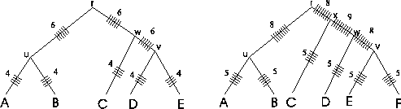
- Circular tours
Definition : A Circular order C(T) of set of sequences S = { s₁, …, s_{n} } is any tour through a tree T(S) where each edge is traversed exactly twice, and each leaf is visited once.
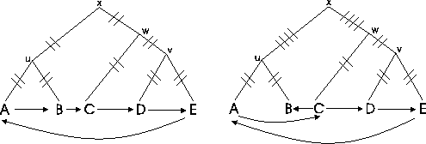
- Traveling Salesman Problem Application
Definition : Let C(S) be the output permutation of a TSP algorithm, then CS_{max}(S) for a given set of sequences S = { s₁, …, s_{n} } is:
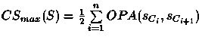where C_{n+1} = C₁.
- Scoring of MSA without evolutionary trees
Definition : The score CS(A)of an MSA A is defined as: 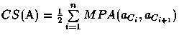where C_{n+1} = C₁.
The maximal score CS_{max}(S) serves as an upper bound for the score of any MSA A that can be built from S :
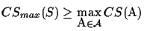
- Result
Figure shows the result for balanced binary trees with 16 leaves. The length of the sequences is 300 amino acids and the average edge distance is 30 PAM

Created by: Kuen-Feng Huang
Method | CS Score
Upper bound: | 22451 ±516
MSA: | 21767 ±513
PAS | 21414 ±481
Real: | 21367± 439
ClustalW: | 21330 ±473
MAP: | 18633± 608
Dummy: | 5948 ±911
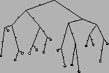
Date : Aug. 31, 2000

